1. Install ARM tools extension in visual studio.

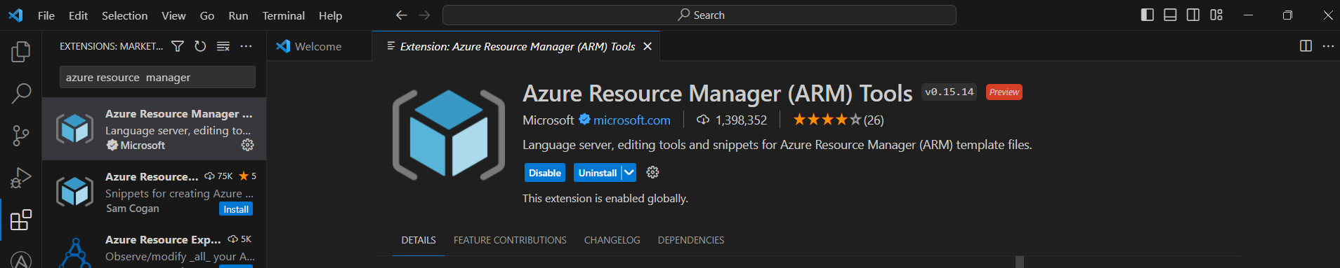

1. Creating template for storage account.

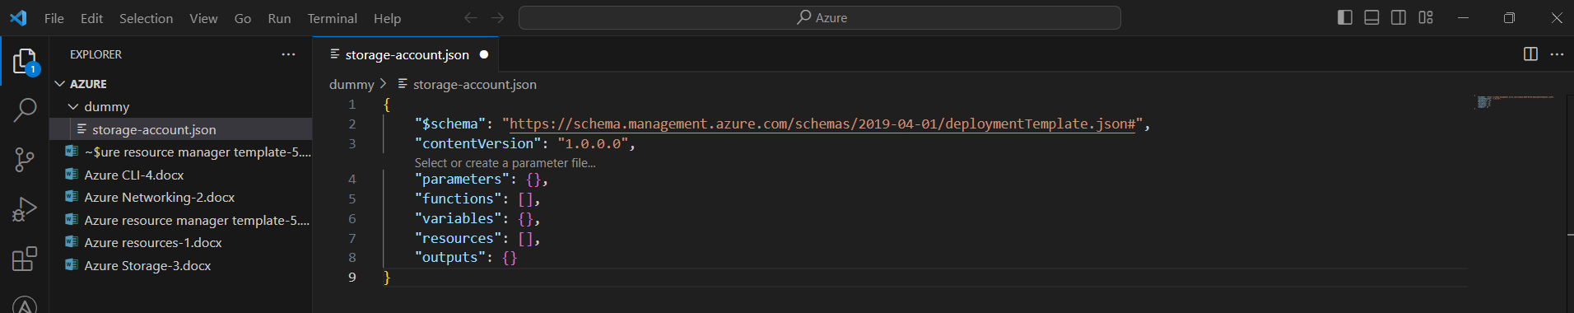

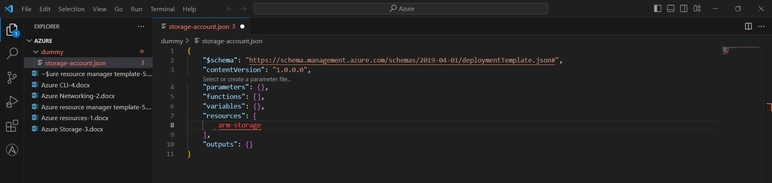

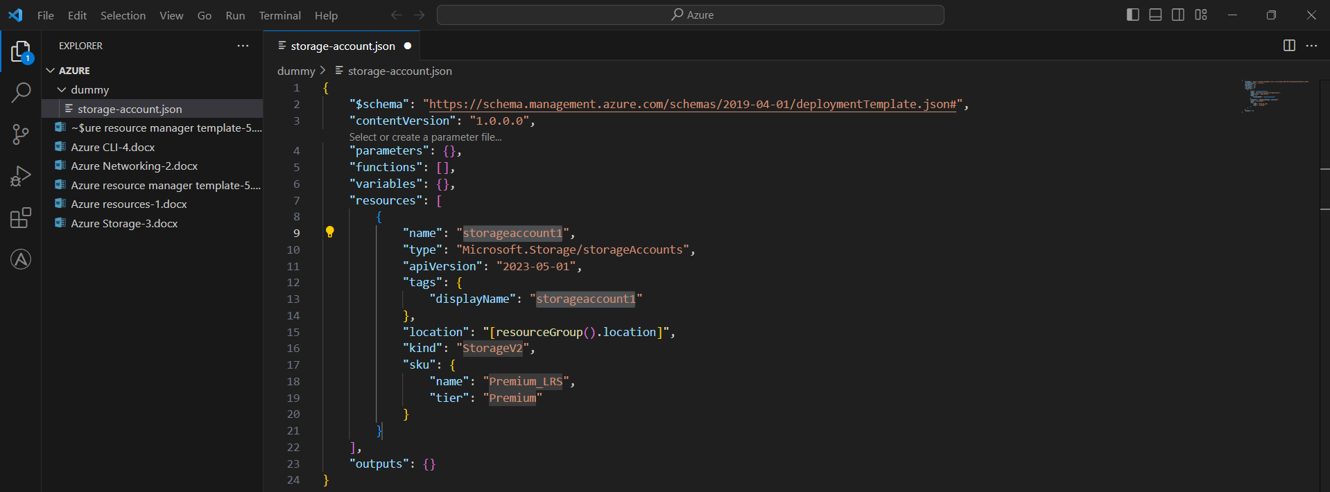

Opened new terminal to run the template.

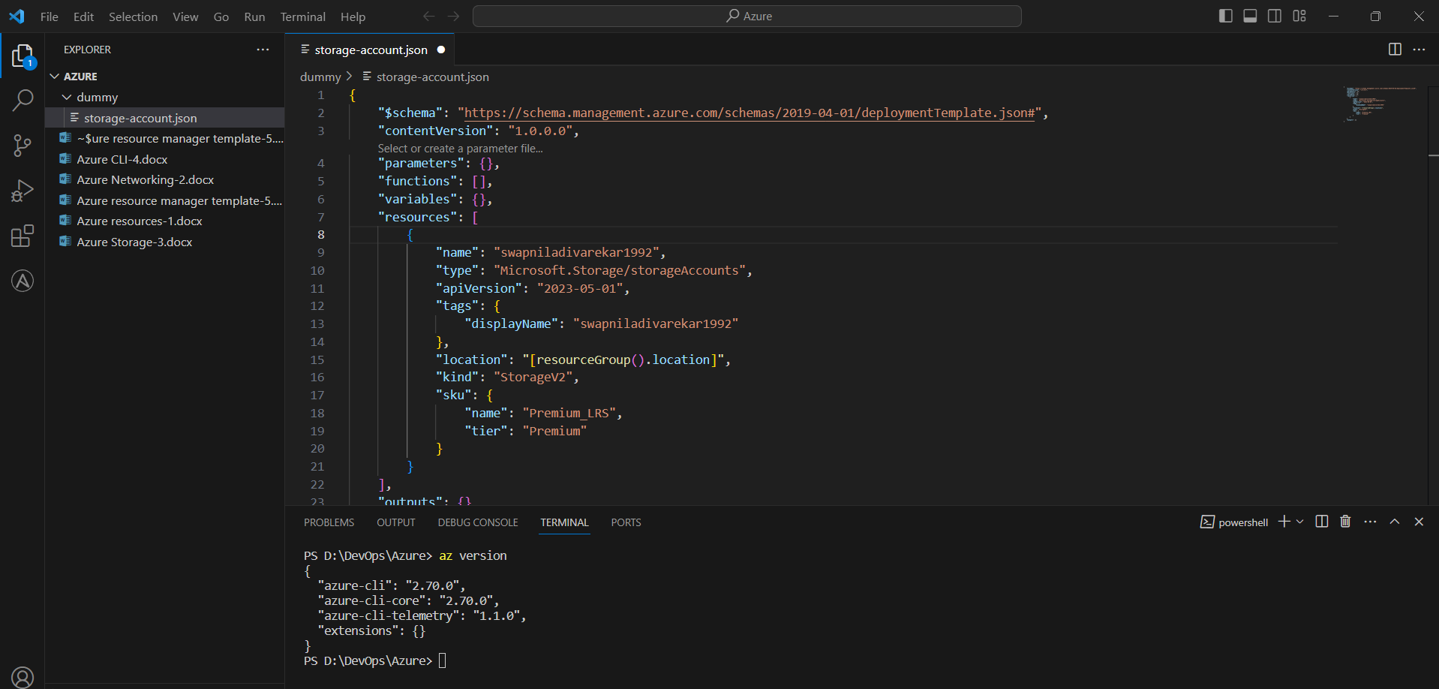

Refer Microsoft tutorials to create template from link below.

https://learn.microsoft.com/en-us/azure/azure-resource-manager/templates/template-tutorial-create-first-template?tabs=azure-powershell

